SYSTEMS DIVISION

IPD Excel Series
TEST PLAN DOCUMENT
WR # 2111

DRAFT

Prepared By:
Back Office IPD Team

1. Excel series load functionality Test 4
1.1. Excel Series Load Test 4
1.1.1. Test Description: 4
1.1.2. Test Environment 4
1.1.3. Expected Results 4
1.1.4. Actual Results 4
2. Excel SERIES FILTER Functionality Test 6
2.1. PROCESSING CODE FILTER Test 6
2.1.1. Test Description: 6
2.1.2. Test Environment 6
2.1.3. Expected Results 6
2.1.4. Actual Results 6
2.2. REPORTING SYMBOL FILTER Test 6
2.2.1. Test Description: 6
2.2.2. Test Environment 6
2.2.3. Expected Results 6
2.2.4. Actual Results 6
2.3. EXPIRATION MONTH FILTER Test 7
2.3.1. Test Description: 7
2.3.2. Test Environment 7
2.3.3. Expected Results 7
2.3.4. Actual Results 7
2.4. EXPIRATION YEAR FILTER Test 7
2.4.1. Test Description: 7
2.4.2. Test Environment 7
2.4.3. Expected Results 7
2.4.4. Actual Results 7
3. Excel SERIES UPDATE Test 9
3.1. excel series 'E' update Test 9
3.1.1. Explain Plan Documentation: 9
3.1.2. Development Performance Times: 9
3.1.3. Outstanding issues from DA: 9
3.2. excel series 'p' update Test 10
3.2.1. Explain Plan Documentation: 10
3.2.2. Development Performance Times: 10
3.2.3. Outstanding issues from DA: 10
4. Excel SERIES DELETE Test 12
4.1. excel series 'E' delete Test 12
4.1.1. Explain Plan Documentation: 12
4.1.2. Development Performance Times: 12
4.1.3. Outstanding issues from DA: 12
4.2. excel series 'p' delete Test 13
4.2.1. Explain Plan Documentation: 13
4.2.2. Development Performance Times: 13
4.2.3. Outstanding issues from DA: 13
5. Excel SERIES validate Test 15
5.1. excel series validate Test 15
5.1.1. Explain Plan Documentation: 15
5.1.2. Development Performance Times: 15
5.1.3. Outstanding issues from DA: 15
6. Excel SERIES APPROVE Test 17
6.1. excel series approve Test 17
6.1.1. Explain Plan Documentation: 17
6.1.2. Development Performance Times: 17
6.1.3. Outstanding issues from DA: 17
7. Excel SERIES APPROVEall Test 18
7.1. excel series approveall Test 18
7.1.1. Explain Plan Documentation: 18
7.1.2. Development Performance Times: 18
7.1.3. Outstanding issues from DA: 18

Excel Series Load Functionality Test

Excel Series Load Test

Test Description:
Verification of Load of both a DailyMMDDYYYY.csv and a LateDlyMMDDYYYY.csv Excel Series spreadsheet. This verification would be done after the GUI load process was complete for both of the spreadsheets, a DailyMMDDYYYY.csv and a LateDlyMMDDYYYY.csv. Both of these spreadsheets should be for the same day.

Test Environment
IPD and ipdsd000
- Number of records on ipd_opt_series_chg that have the column src_file_name the same as the name of the excel spreadsheet is the same as the number of records on the spreadsheet.
select count(*)
from ipd_opt_series_chg
where src_file_name = ‘name of spreadsheet’;

Number of rows on IPD_OPT_SERIES_CHG having SRC_FILE_NAME = ‘DailyMMDDYYYY.csv’ | Number of series in Excel Series Spreadsheet DailyMMDDYYYY.csv | Number of rows on IPD_OPT_SERIES_CHG having SRC_FILE_NAME = ‘LateDlyMMDDYYYY.csv’ | Number of series in Excel Series Spreadsheet LateDlyMMDDYYYY.csv

Expected Results
- Number of records for the DailyMMDDYYYY.csv select should match the number of series on the Excell spreadsheet with that name
- Number of records for the LateDlyMMDDYYYY.csv select should match the number of series on the Excell spreadsheet with that name

Actual Results
The numbers in the table above.
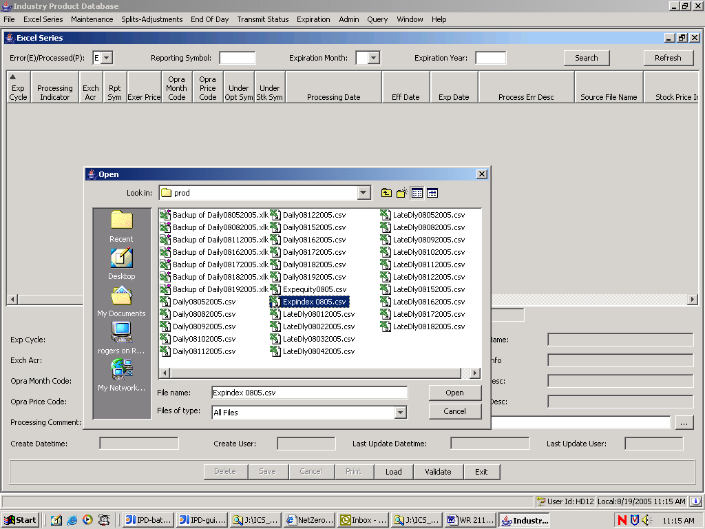

To initiate the load test select Excel Series from the menu bar, click the Load button on the Excel Series screen, select the Excel Series spreadsheet that you wish to load, in this case ExpIndex 0805.csv, press the Open button , and answer ‘Yes’ to the confirmation prompt that follows.

Excel Series Filter Functionality Test

PROCESSING CODE FILTER Test

Test Description:
Verification that the GUI only displays ‘E’ records when Processing Code ‘E’ is selected on the dropdown and the Search button is pressed. This is client filtering so no server data access is involved. Also do the same by Processing Code ‘P’ and pressing the Search button

Test Environment
IPD and ipdsd000
- Records displayed should only be those whose processing code is identical to the selected processing code.
- (‘E’ records are those records that were loaded and did not pass validation and ‘P’ records are those that were loaded and did pass validation).
- Make sure that the other filtering (reporting symbol, expiration month, expiration year) is turned off.

Expected Results
- Only ‘E’ records are displayed if Processing Code ‘E’ was selected and only ‘P’ records are displayed of Processing Code ‘P’ was selected.
- There may be no selected records resulting in an empty screen

Actual Results
The GUI screen should not display any records other than those having the same Processing Code as the selected Processing Code.

REPORTING SYMBOL FILTER Test

Test Description:
All filtering will include the Processing Code filtering. It is not possible to search and display both ‘E’ and ‘P’ records. The Reporting Symbol filtering will function as a sub filter under the main Processing Code filter. Only those series having the same Reporting Symbol as designated in the filter criteria will be displayed on the screen after the Search button is pressed.

Test Environment
IPD and ipdsd000
- Records displayed should only be those whose processing code is identical to the selected processing code and whose Reporting Symbol is the same as the Reporting Symbol keyed in the Reporting Symbol filter field..
- Make sure that the other filtering (expiration month, expiration year) is turned off.

Expected Results
- Only records having the filtered Reporting Symbol are displayed..
- There may be no selected records resulting in an empty screen

Actual Results
The GUI screen should not display any records other than those having the same Reporting Symbol as the filtering Reporting Symbol.

EXPIRATION MONTH FILTER Test

Test Description:
All filtering will include the Processing Code filtering. It is not possible to search and display both ‘E’ and ‘P’ records. The Expiration Month filtering will function as a sub filter under the main Processing Code filter. Only those series having the same Expiration Month as designated in the filter criteria will be displayed on the screen after the Search button is pressed.

Test Environment
IPD and ipdsd000
- Records displayed should only be those whose processing code is identical to the selected processing code and whose Expiration Month is the same as the Expiration Month selected in the Expiration Month filter field..
- Make sure that the other filtering (reporting symbol, expiration year) is turned off.

Expected Results
- Only records having the filtered Expiration Month are displayed..
- There may be no selected records resulting in an empty screen

Actual Results
The GUI screen should not display any records other than those having the same Expiration Month as the filtering Expiration Month.

EXPIRATION YEAR FILTER Test

Test Description:
All filtering will include the Processing Code filtering. It is not possible to search and display both ‘E’ and ‘P’ records. The Expiration Month filtering will function as a sub filter under the main Processing Code filter. Only those series having the same Expiration Month as designated in the filter criteria will be displayed on the screen after the Search button is pressed.

Test Environment
IPD and ipdsd000
- Records displayed should only be those whose processing code is identical to the selected processing code and whose Expiration Month is the same as the Expiration Month selected in the Expiration Month filter field..
- Make sure that the other filtering (reporting symbol, expiration year) is turned off.

Expected Results
- Only records having the filtered Expiration Month are displayed..
- There may be no selected records resulting in an empty screen

Actual Results
The GUI screen should not display any records other than those having the same Expiration Month as the filtering Expiration Month.

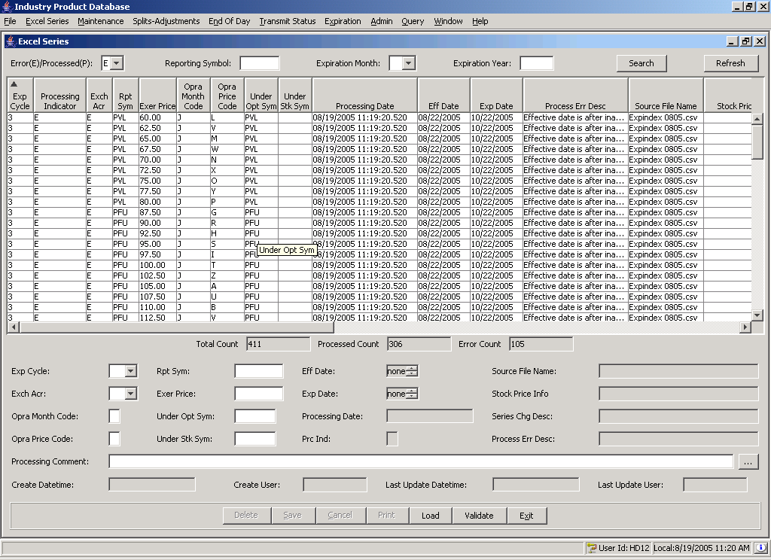

The filter fields and buttons are at the top of the Excel Series screen. The Processing Code is a drop down that allows you to select either ‘E’ or ‘P’. Reporting symbol is keyed in and is changed to caps if necessary, Expiration Month is a drop down varying from ‘01’ – ‘12’. Expiration Year is a 4 digit year. All the filter fields allow spaces meaning ALL, except Processing Code that must be ‘E’ or ‘P’. Search will filter the table data based on the filtering criteria. The refresh button next to search will actually go to the server and retrieve all the data on ipd_opt_series_chg,

Excel SERIES UPDATE Test

EXCEL SERIES 'E' UPDATE Test

Test Description:
Update an excel series record having an ‘E’ processing code. The following fields will be updated: Exp Cycle, Rpt Sym, Eff Date, Exer Price, Exp Date, Opra Month Code, Under Opt Sym, Opra Price Code, Under Stk Sym, and Processing Comments. In order to do this, filter on ‘E’ and then select one of the ‘E’ records. This will populate the bottom of the screen with the updateable detail.. Save will be enabled as soon as you key in new data. Pressing save will save it to the ipd_opt_series_chg table. If the record passes validation you will have to filter on ‘P’ processing code to view it. If it does not the error causing validation failure will appear in the Process Err Desc textbox. In either case the data will be changed on the table. The logical key of rptSym, expr_date, and exer_price can be used to verify the screen against the table contents.

Test Environment
IPD and ipdsd000
- The following SQL will verify that what appears on the screen is what is on the database.
select expr_cyc_code expCyle,
class_sym rptSym,
ipd_owner.convert_java_time(eff_date) effDate,
exer_price exerPrice,
ipd_owner.convert_java_time(expr_date )expDate,
opra_month_code opraMonthCode, under_sec_sym underOptSym,
opra_price_code opraPriceCode, trade_inst_sym underStkSym,
proc_comment_text processingComments
from ipd_opt_series_chg
where class_sym = 'PDU'
and trunc(ipd_owner.convert_java_time(expr_date), 'DD') = '20-Aug-2005'
and exer_price = 17.50;

where ‘PDU’, ’20-Aug-2005’ and 17.50 are the current values on the screen.

Expected Results
- rptSym, effDate, exerPrice, expDate, opraMonthCode, underOptSym, opraPriceCode, underStkSym, and processingComments on the table are the same as that on the screen.

Actual Results
The output of the select vs. the contents of the GUI.

EXCEL SERIES 'P' UPDATE Test

Test Description:
Update an excel series record having an ‘P’ processing code. The following fields will be updated: Exp Cycle, Rpt Sym, Eff Date, Exer Price, Exp Date, Opra Month Code, Under Opt Sym, Opra Price Code, Under Stk Sym, and Processing Comments. In order to do this, filter on ‘P’ and then select one of the ‘P’ records. This will populate the bottom of the screen with the updateable detail.. Save will be enabled as soon as you key in new data. Pressing save will save it to the ipd_opt_series_chg table. If the record does not pass validation you will have to filter on ‘E’ processing code to view it. The error causing validation failure will appear in the Process Err Desc textbox. In either case the data will be changed on the table. The logical key of rptSym, expr_date, and exer_price can be used to verify the screen against the table contents.

Test Environment
IPD and ipdsd000
- The following SQL will verify that what appears on the screen is what is on the database.
select expr_cyc_code expCyle,
class_sym rptSym,
ipd_owner.convert_java_time(eff_date) effDate,
exer_price exerPrice,
ipd_owner.convert_java_time(expr_date )expDate,
opra_month_code opraMonthCode, under_sec_sym underOptSym,
opra_price_code opraPriceCode, trade_inst_sym underStkSym,
proc_comment_text processingComments
from ipd_opt_series_chg
where class_sym = 'PDU'
and trunc(ipd_owner.convert_java_time(expr_date), 'DD') = '20-Aug-2005'
and exer_price = 17.50;

where ‘PDU’, ’20-Aug-2005’ and 17.50 are the current values on the screen.

Expected Results
- rptSym, effDate, exerPrice, expDate, opraMonthCode, underOptSym, opraPriceCode, underStkSym, and processingComments on the table are the same as that on the screen.

Actual Results
The output of the select vs. the contents of the GUI.
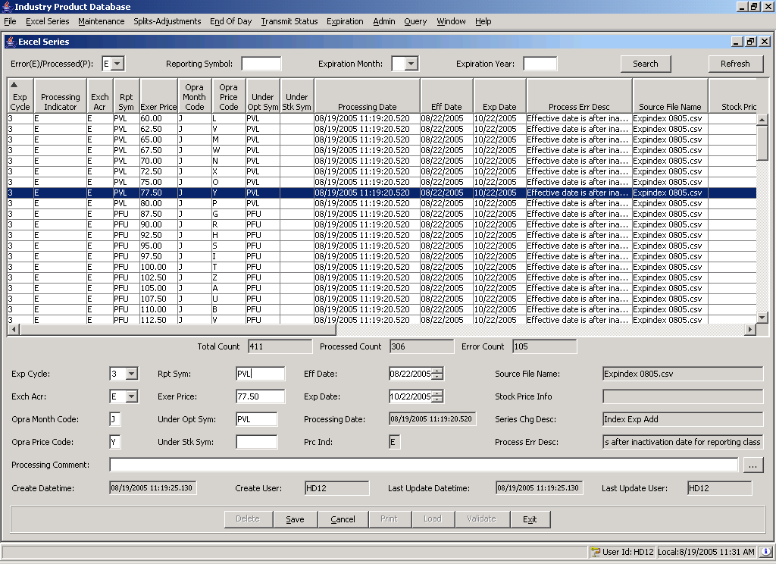

The update process works essentially the same for ‘E’ and ‘P’ records. The current record may be updated by changing data on the bottom of the screen and then pressing the Save button. The Save and Cancel buttons are activated by entering data in any one of the editable fields.

Excel SERIES DELETE Test

EXCEL SERIES 'E' DELETE Test

Test Description:
Excel Series has three kinds of deletes: 1. Delete by Filename, 2. Delete by Expiration Date, and 3. Delete current record. To test these deletes make sure that you have all the records on the ipd_opt_series_chg table by pressing the Refresh button. Make sure that there are enough records on the screen with an ‘E’ status to go through the delete process for ‘E’ processing code records.. If there aren’t, you may have to load another table or edit ‘P’ status records to change their processing code to ‘E’. First delete the current record and verify that it is not on the table. Second, select an expiration date, delete it, and verify that no record with that expiration date is on the table. Third, select a file name, delete it, and verify that no record with that file name is on the table.

Test Environment
IPD and ipdsd000
- The following SQL will verify that the current record is deleted
select ‘1’
from ipd_opt_series_chg
where class_sym = 'PDU'
and trunc(ipd_owner.convert_java_time(expr_date), 'DD') = '20-Aug-2005'
and exer_price = 17.50;
where ‘PDU’, ’20-Aug-2005’ and 17.50 are values of the current record that was deleted.

- The following SQL will verify that the records with the selected source file name were deleted
select ‘1’
from ipd_opt_series_chg
where src_file_name = 'Daily08112005.csv’;
where ‘Daily08112005.csv’ is value of the selected file that was deleted.

- The following SQL will verify that the records with the selected expiration date were deleted
select ‘1’
from ipd_opt_series_chg
where trunc(ipd_owner.convert_java_time(expr_date), 'DD') = '20-Aug-2005';
where ’20-Aug-2005’ is value of the selected expiration date that was deleted.

Expected Results
- All three selects should return no rows or an empty result set if the delete correctly worked.

Actual Results
The output of the select. Records returned mean the delete test did not pass.

EXCEL SERIES 'P' DELETE Test

Test Description:
Excel Series has three kinds of deletes: 1. Delete by Filename, 2. Delete by Expiration Date, and 3. Delete current record. To test these deletes make sure that you have all the records on the ipd_opt_series_chg table by pressing the Refresh button. If ‘ E’ records are displayed you need to select ‘P’ and then press the Search button. Make sure that there are enough records on the screen with an ‘P’ status to go through the delete process for ‘P’ processing code records.. If there aren’t, you may have to load another table or edit ‘E’ status records to change their processing code to ‘P’. First delete the current record and verify that it is not on the table. Second, select an expiration date, delete it, and verify that no record with that expiration date is on the table. Third, select a file name, delete it, and verify that no record with that file name is on the table.

Test Environment
IPD and ipdsd000
- The following SQL will verify that the current record is deleted
select ‘1’
from ipd_opt_series_chg
where class_sym = 'PDU'
and trunc(ipd_owner.convert_java_time(expr_date), 'DD') = '20-Aug-2005'
and exer_price = 17.50;
where ‘PDU’, ’20-Aug-2005’ and 17.50 are values of the current record that was deleted.

- The following SQL will verify that the records with the selected source file name were deleted
select ‘1’
from ipd_opt_series_chg
where src_file_name = 'Daily08112005.csv’;
where ‘Daily08112005.csv’ is value of the selected file that was deleted.

- The following SQL will verify that the records with the selected expiration date were deleted
select ‘1’
from ipd_opt_series_chg
where trunc(ipd_owner.convert_java_time(expr_date), 'DD') = '20-Aug-2005';
where ’20-Aug-2005’ is value of the selected expiration date that was deleted.

Expected Results
- All three selects should return no rows or an empty result set if the delete correctly worked.

Actual Results
The output of the select. Records returned mean the delete test did not pass.
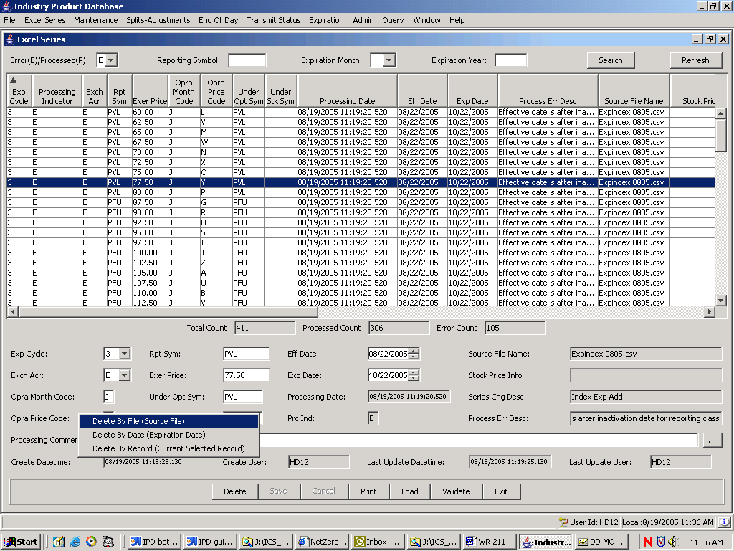

The Delete processing may be initiated by pressing the Delete button at the bottom of the screen, and selecting one of the three selections on the popup menu that is activated. The delete process works essentially the same for ‘E’ and ‘P’ records.

Excel SERIES VALIDATE Test

EXCEL SERIES VALIDATE Test

Test Description:
The Validate button is designed to validate the ipd_occ_series_chg table and send the results back to the screen. In case a reporting class was missing, the user may add the reporting class and then Validate the Excel Series records to change their status from ‘E’ to ‘P’. However the total number of records should not change. Do a Refresh to make sure that the GUI has the entire Excel Series Staging table, the ipd_occ_series_chg. Note the total count. Now press the Validate Button. The total count should not have changed. Finally, verify tha count by executing the SQL below.

Test Environment
IPD and ipdsd000
- The following SQL will verify the total number of records on the Excel Series Staging table.
select count(*)
from ipd_opt_series_chg;

Expected Results
- All three counts: 1. before the validate, 2. after the validate, 3. the output of the select should be the same.

Actual Results
The output of the select and counts displayed on the screen.

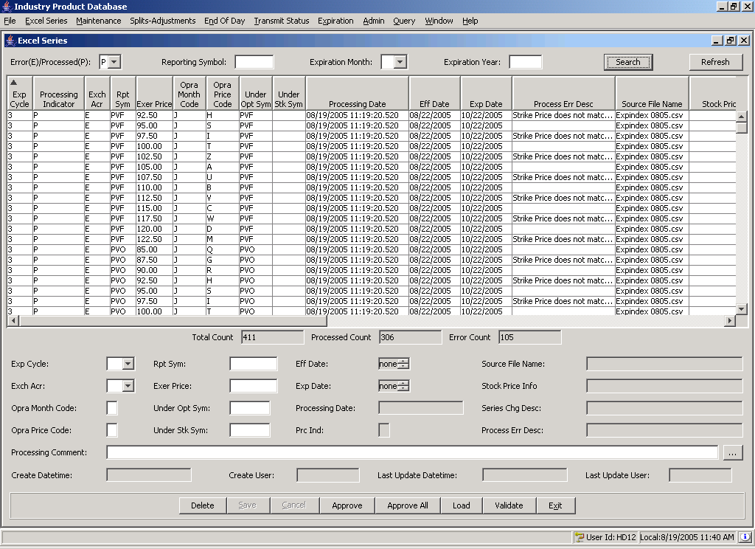

The Validate Process is initiated by pressing the Validate button at the bottom of the screen. It is essentially the same for both ‘E’ and ‘P’ records. The Approve and Approve All processing is initiated by pressing the Approve or Approve All buttons at the bottom of the Excel Series screen that displays ‘P’ records. ‘P’ records are records that have passed validation and are ready for approval.

Excel SERIES APPROVE Test

EXCEL SERIES APPROVE Test

Test Description:
The Appove Button will take the selected record and migrate it to the IPD product table. The status in ipd_opt_series_chg will be changed to ‘A’ when this happens and effectively disappear from the Excel Series Maintenance screens. And end of day process will delete all the approved records from the Excel Series staging table, ipd_opt_series_chg.

Test Environment
IPD and ipdsd000
- The following SQL will verify the new product on the product table in the IPD database
select class.class_sym rptClass,
prod.prod_name prodName,
prod.exer_price exerPrice,
ipd_owner.convert_java_time(prod.expr_date )expDate
from product prod, rpt_class class
where class.databaseidentifier = prod.rpt_class
and class.class_sym = 'TCF'
and trunc(ipd_owner.convert_java_time(prod.expr_date), 'DD') = ’22-Oct-2005'
and prod.exer_price = 5.00;

where ‘TCF’, ’22-Oct-2005’ and 5.00 are the values of the excel series that was approved.

Expected Results
- The result set should be 2 records, one put and one call

Actual Results
The output of the select.

Excel SERIES APPROVEALL Test

EXCEL SERIES APPROVEALL Test

Test Description:
The Appove All Button will migrate all the ‘P’ records displayed on the GUI to the IPD product table. The status in ipd_opt_series_chg will be changed to ‘A’ when this happens and effectively disappear from the Excel Series Maintenance screens. And end of day process will delete all the approved records from the Excel Series staging table, ipd_opt_series_chg.

Test Environment
IPD and ipdsd000
- The following SQL will verify the new product on the product table in the IPD database. The tester should test 3 – 5 records that are approved using essentially the same SQL as the APPROVE test.
select class.class_sym rptClass,
prod.prod_name prodName,
prod.exer_price exerPrice,
ipd_owner.convert_java_time(prod.expr_date )expDate
from product prod, rpt_class class
where class.databaseidentifier = prod.rpt_class
and class.class_sym = 'ARO'
and trunc(ipd_owner.convert_java_time(prod.expr_date), 'DD') = ’22-Oct-2005'
and prod.exer_price = 20.00;

where ‘ARO’, ’22-Oct-2005’ and 20.00 are the values of the excel series that was approved.

Expected Results
- The result set should be 2 records, one put and one call

Actual Results
The output of the select.

